*Cover page*

About this Tutorial
In this tutorial, you will learn to create a feature code library in Origin. The tutorial will walk you through importing a job file (in the downloaded folder), containing points from a parking lot survey. This tutorial does not involve a lot of technical procedure (setting up a survey), it will just walk you through how to create a feature code library in Origin. You will learn how to do the following:
- Upload a job file
- Create a feature code library in Origin and assign it to the job
- Change, edit, and make notes on points with codes.
- Key in points, using the feature codes
This tutorial will take approximately 15-20 minutes to complete.

Understanding Feature Codes in Origin
A feature code library is a text file that contains the definitions of features, attributes, linework, and control codes. When measuring a point in the field, you can assign it a feature code to define what that point represents.
You can download or create a feature code library prior to field work. Typically, it is best practice to create a feature code library in the office and to have a standard process for coding points consistently. If you do not have one, Origin has a tool to create these libraries on the fly or add codes to the library if you find there are codes missing. Users can configure a very limited set of properties in Origin; however, using the feature definition manager allows for more configuration.

What You Will Need
- Origin Field Software: Origin LT, Origin Max, Origin GNSS, or Origin Total Station
- Device: computer or data collector
- Data: Ensure the jobXML file, downloaded in the CreatingaFeatureCodeLibrary folder, is located on your device.

Step 1: Create a Project and Job
- In the Projects screen, tap New.
- Fill in the project details:
Name the project “Feature Codes”
(Optional) Provide a Description “learning to create feature codes”
- Tap Enter and Create
- In the New job screen, select Create from JobXML or DC file and change the settings to the following
Name the job “Create a Feature Code Library”
For File format, select JobXML
For From file:
Browse to the downloaded CreatingFeatureCodeLibrary.jxl file and select.
Tap Enter.
- A pop-up box will appear showing Transfer complete.
- The properties page will appear, there will be no changes made to the job right now.
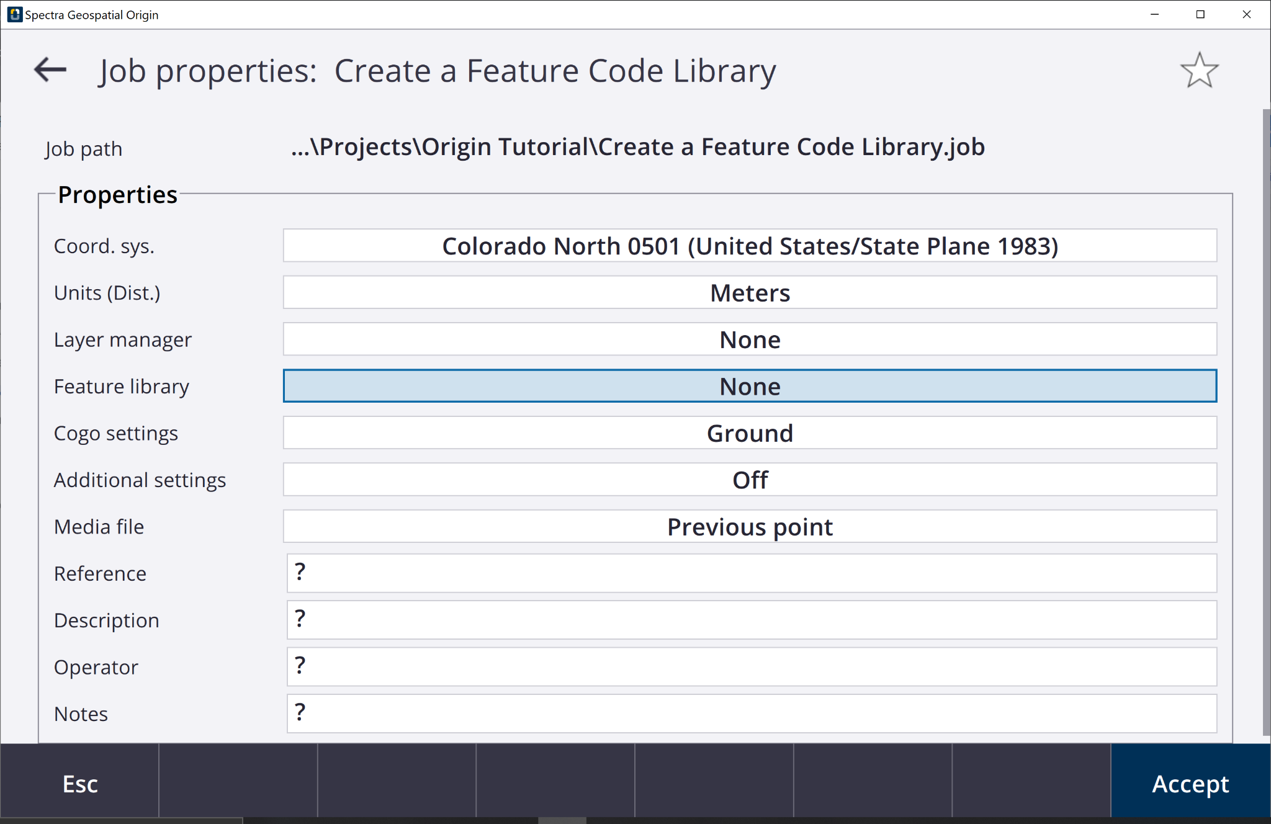
- Tap Accept and the Map screen will appear with the data.
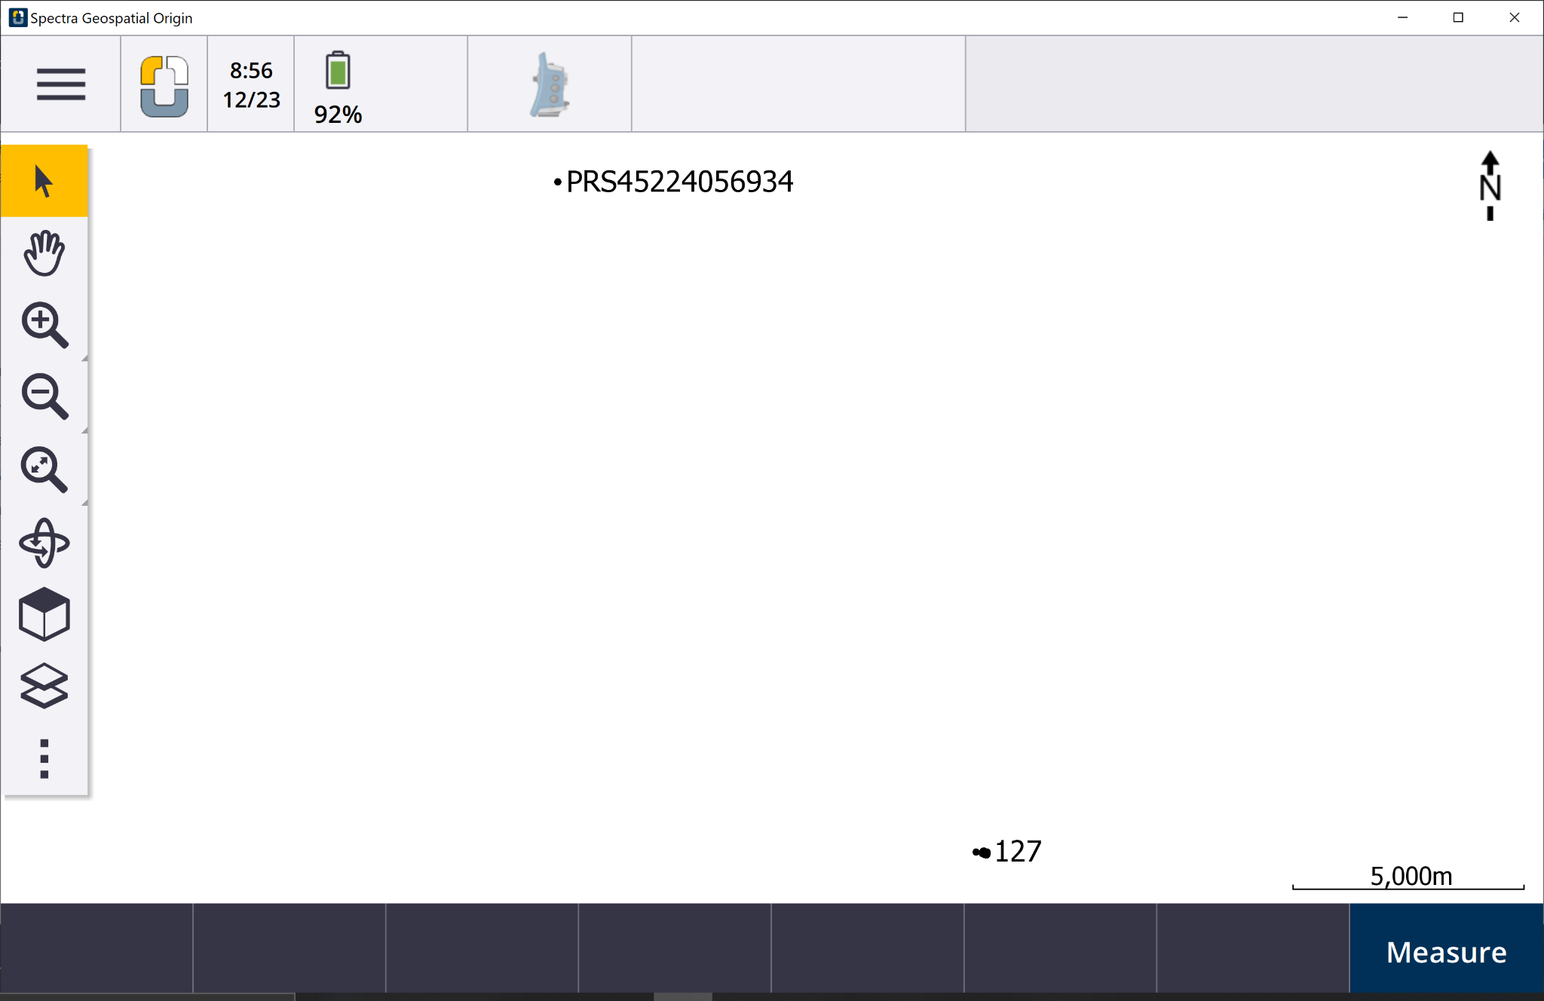
- Tap and hold the Zoom In toolbar for 3 seconds, tap in the map multiple times to zoom in on point 127.
Additionally, you can tap Zoom in and drap a box around point 127.
- There are several data points collected from a parking lot survey.
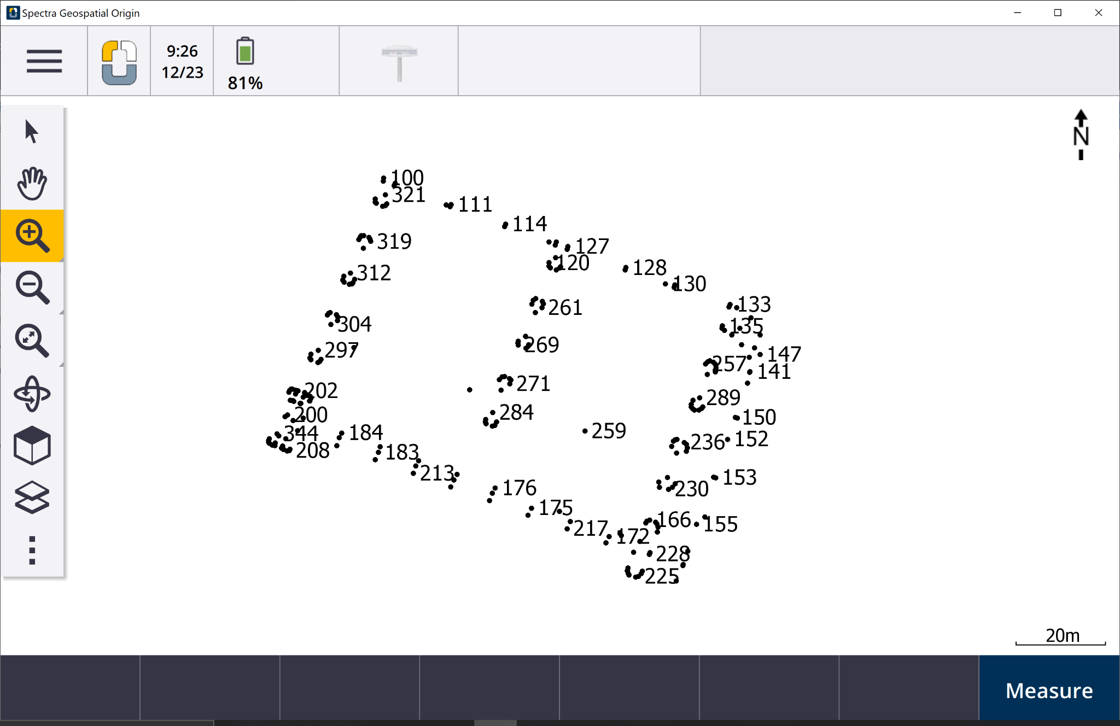
- This job contains many points, lines, and polygons. However, there is not a feature library assigned so the codes have no definitions.
The following tutorial steps will make the feature library for this data set and give the points their definitions.

Step 2: Creating a New Feature Code Library
- Tap.
- Tap Settings and Feature libraries.
You will see the GlobalFeatures already listed. This is a default feature code library.
- Tap New and in the Feature library details page, give the name “WCO Parking Lot”.
Tap Enter and Accept.
- Back on the Feature Libraries page, select the WCO Parking Lot and you will be brought to the feature list.
Since you have not added any features, it will say No features exist.
- On the bottom of the screen, tap Add. You will be adding in points, lines, and polygons.
- On the Enter feature code screen. Fill in the following information:
Feature code: BOC
Description: Back of Curb
Feature Type: Line
Layer: 0
Line Style: Solid Line
Line Color: Orange
Tap Accept and the new feature code is added to the list.
- Tap Add and repeat Step 6 for the following feature codes:

Feature Code | Description | Feature Type | Layer | Detail:  (Line Style, Line/Border Color,  Control code action)
LP | Light Pole | Point | 0 | N/A
WALL | Wall | Line | 0 | Solid lines  Red
CNTL | Control Point | Point | 0 | N/A
TREE | Tree | Point | 0 | N/A
SW | Sidewalks | Line | 0 | Solid Lines  Yellow
LND | Landscape | Polygon | 0 | Solid Lines  Green
S | Start Line | Control code | 0 | Start join sequence
E | End Line | Control code | 0 | End join sequence
- Tap Store and Back. You will be brought to the Map screen.
- Tap.
- Tap the Job: Creating a Feature Code Library.
- You should be on the Origin Tutorial project page, tap the Creating a Feature Code Library job.
Tap Properties.
- You can see there is no Feature Library assigned for the project.
Tap the box and you will see the “WCO Parking Lot” library.
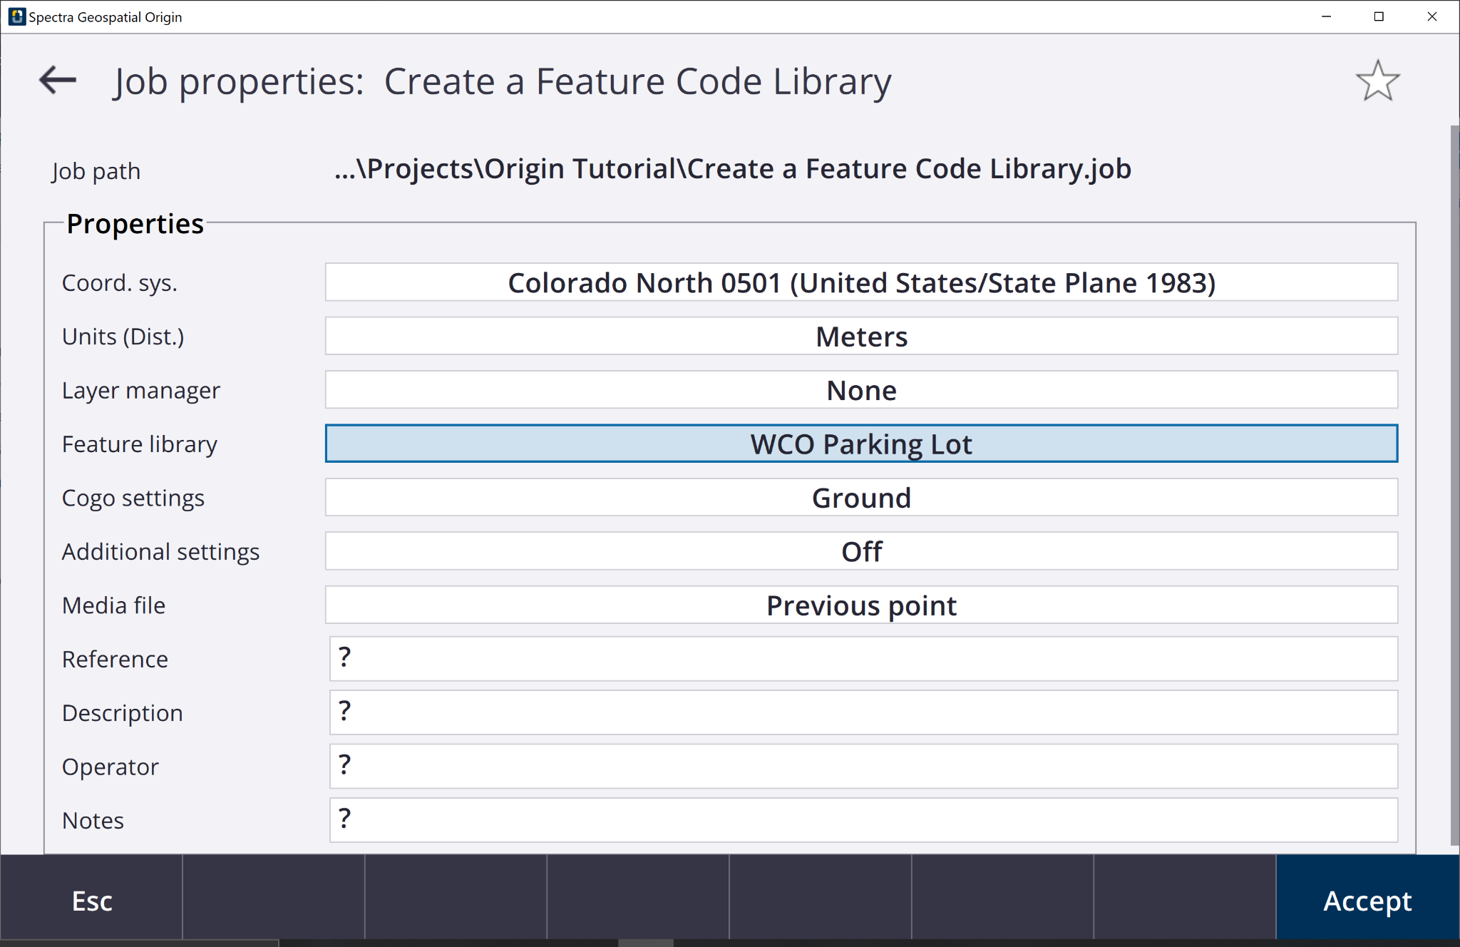
- Tap Accept.
- You have assigned the new Feature Library to the job.
- Navigate to the Map and you will see the points with the outlined definitions.
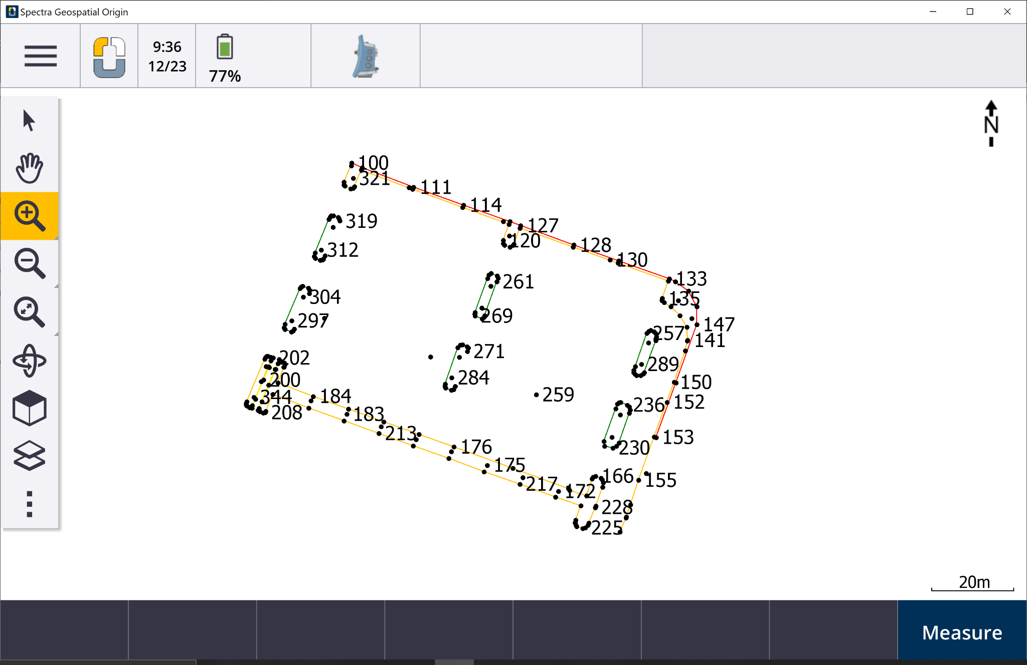
- To see the linework, tap the Layer manager button in the side map controls.
- Select the Filter tab.
- Uncheck the Keyed in points (normal) and you will be able to see the highlighted features.
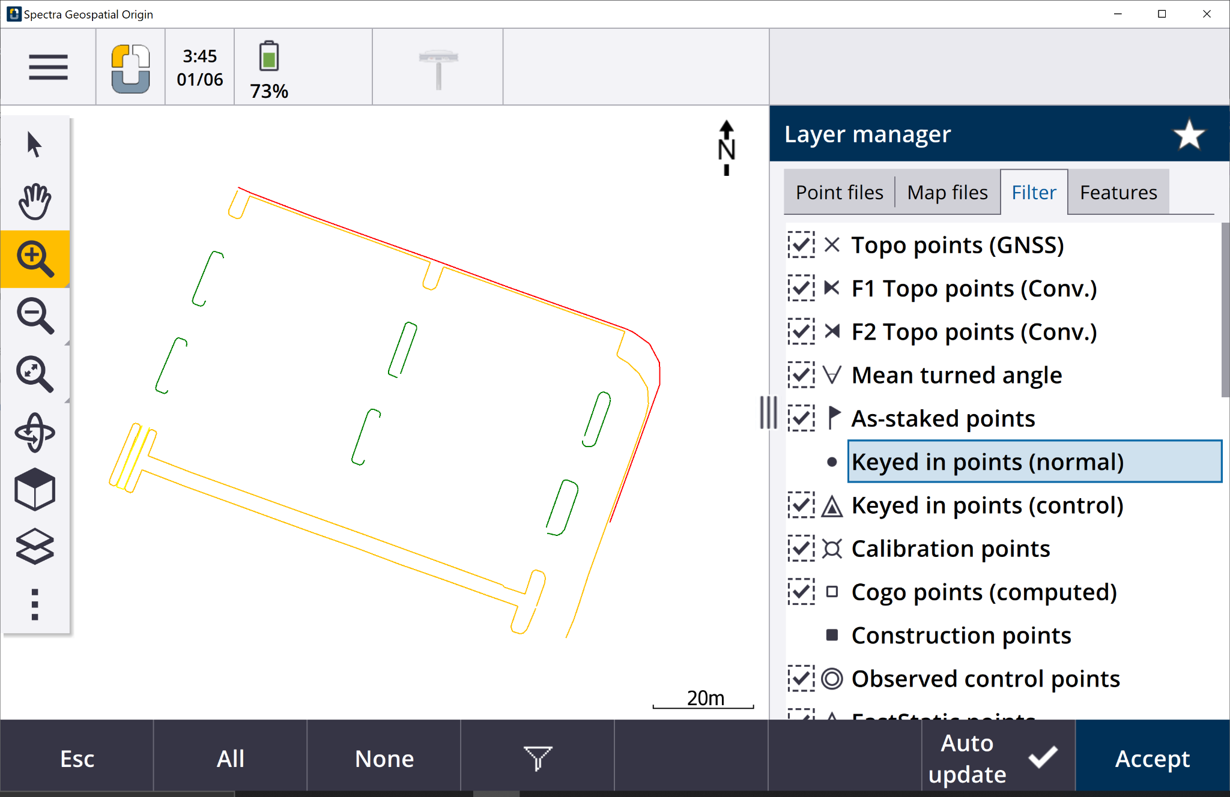

Step 3: Changing Point Codes
- Origin allows for users to change the code for a point that has already been measured.
Tap .
- In the Favorites tab, select Point manager.
Alternatively, tap Job data and Point manager
- All points, from 100 to 344, are listed in the Point manager screen.
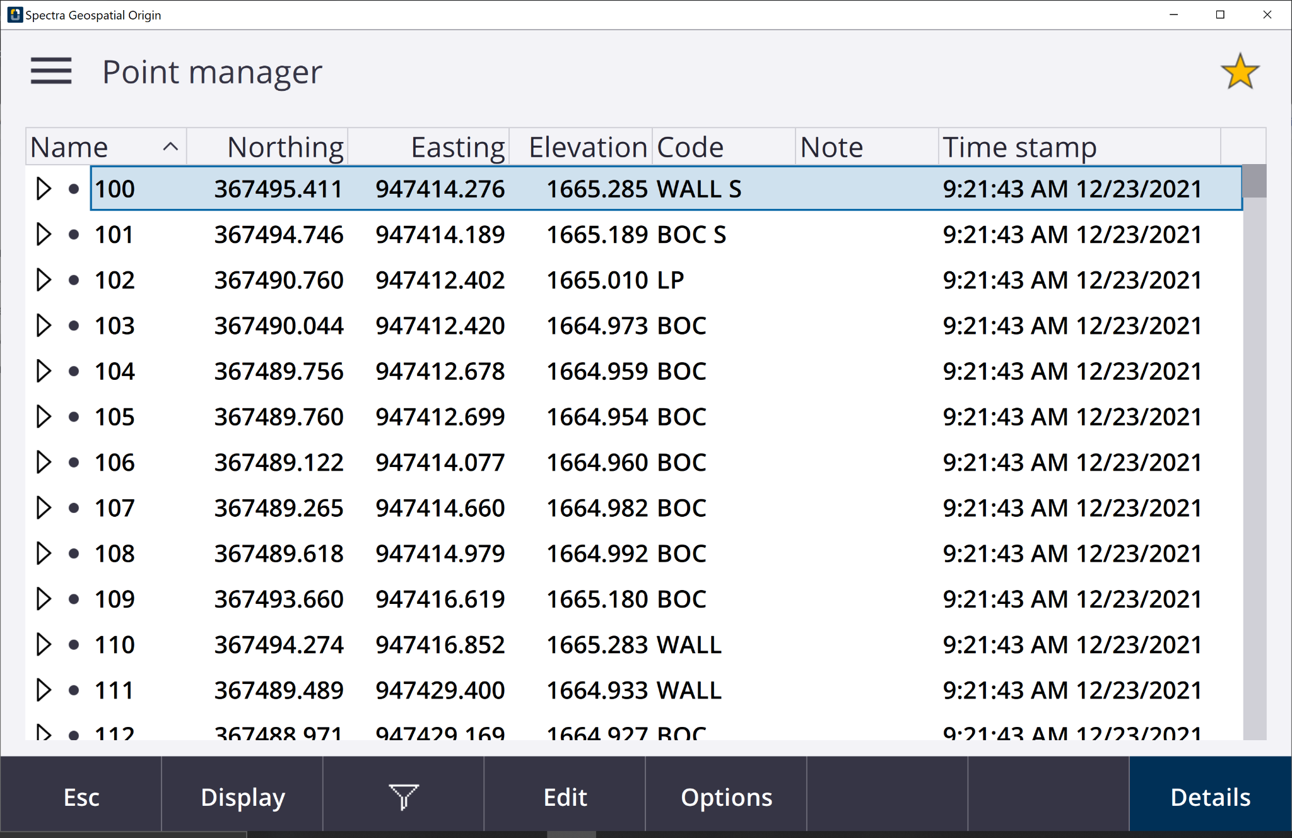
- Look at point 102, it has a code of LP, indicating it is a light pole. This should have the code BOC.
For point 102, tap directly into the Code field to change.
- Clear the search bar and type BOC.
Tap Enter to change the code name.
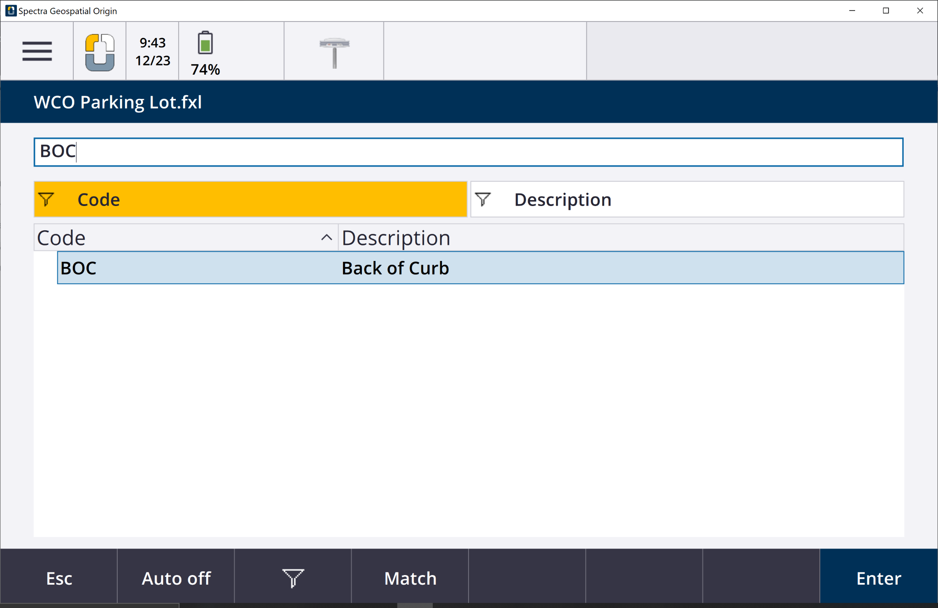
- Tap Enter. Point 102 now has a note that shows it was modified.
Extend the Notes column and it says Modified, Time, and Date.
- In the Point manager page, select point 100.
Tap Edit and then tap Notes.
- In the Notes screen, type Beginning of wall on the edge of the parking lot.
Tap Enter.
- Tap Esc. to go back to the menu.

Step 4: Key-in Points
Now that you have assigned the feature library and uploaded the data, you will key-in points to use the codes. The Key In tool allows for creating points/lines/polygons and entering coordinates of them.
- Tapand tap Key in and select Points.
- For Point name type 345
For Code select TREE
Tap the screen near point 321 to automatically fill in the Northing and Easting boxes.
Type the elevation at 1,524m.
Tap Store.
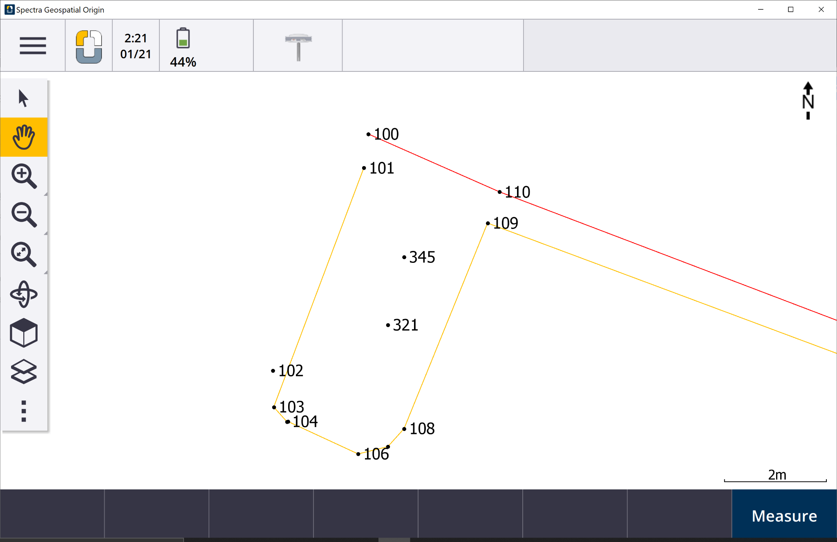
You have completed this tutorial.

