*Cover page*
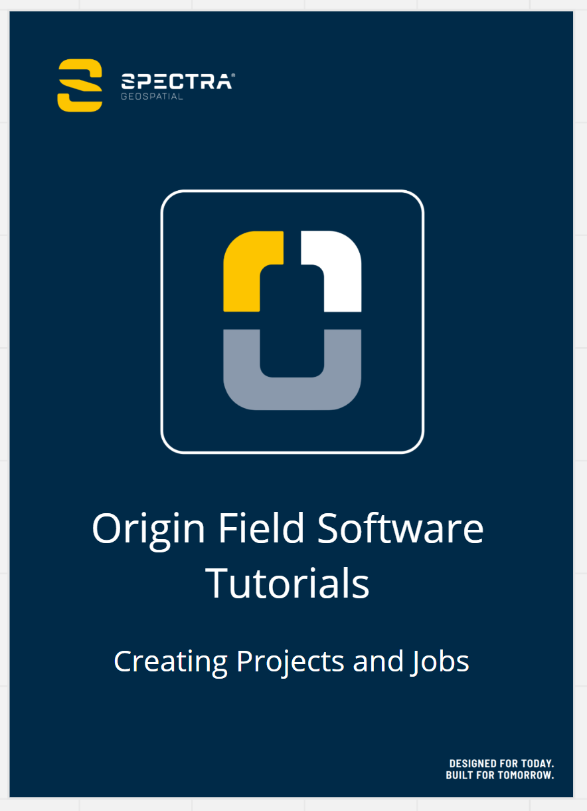

About this Tutorial
In this tutorial, you will learn how to create a project and job in Origin, including:
- Create projects and jobs locally on a controller
- Import data into a new job
- Save your project to Trimble Connect
- Export the job file
This tutorial will take about 10-15 minutes to complete.

Understanding Projects and Jobs in Origin
To start a survey, you must have at least one project and one job. Once a job has been created, you can import data or link data files. A project is a folder for grouping Origin jobs and the files used by those jobs, including control points, road or alignment RXL files, background images or surfaces, and reference files for the project such as site or health and safety information. A job contains the raw survey data from one or more surveys, and the configuration settings for the job including coordinate system, calibration, and measurement unit settings. Once a job has been created, you can import data to make the points become a part of the job.

What You Will Need
- Origin Field Software: Origin LT, Origin Max, Origin GNSS, or Origin Total Station
- Trimble Connect - optional
- Device: computer or data collector
- Data: Ensure the data used in this tutorial is located on your device. You can use the data that came in the downloaded CreatingProjects&Jobs folder, or, you can use your own data.

Step 1: Sign In to Trimble Connect
Note: If you are not using Trimble Connect, skip to Step 2.
- When you start Origin, you need to select or create a new Project.
Tap the Trimble Connect icon in the top right corner to sign in.
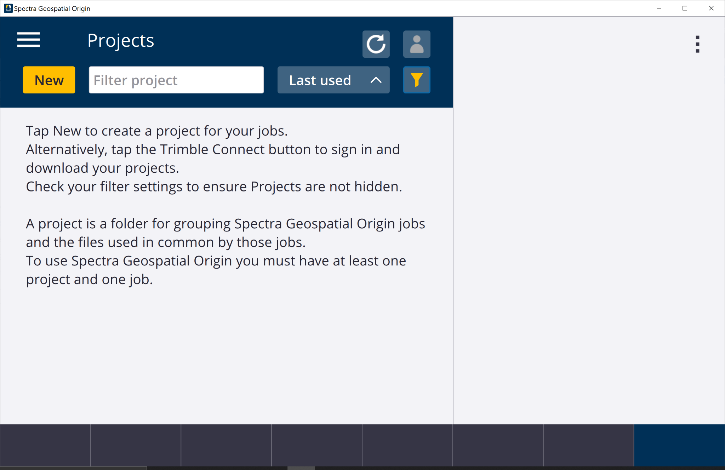
- A new screen will appear, tap Sign in using Trimble ID, then an internet tab will appear in your default browser.
Fill in your Trimble ID information.
- Now that you are signed in, the Trimble Connect icon is colored yellow .

Step 2: Create a New Project
Note: The project is set up in Westminster, Colorado (U.S.). The data used later in the tutorial matches the coordinate system. If you would like to import your own data, set your coordinate system up with your projection.
- On the Projects screen, tap New in the top left corner of the screen.
- In the New project screen, fill in the project details (not all of the details are required).
Name the project Creating Projects and Jobs
(Optional) Provide a Description Origin tutorial
(Optional) Provide a Reference
(Optional) Include a Location Westminster, CO, or your location
(Optional) Include an Image
Note: If your device has a camera, you can select the Camera button to take a picture of your site. This will be the image that is shown on the Cloud.
- Tap Enter and Create, and the project will be created.
- In the New job screen, tap Create from template and set up the job with the following details and properties:
Name: Month, Year (January, 2022)
Template: Metric Scale Only
Coord. sys. and tap Select from library, which will bring you to the coordinate system database. Input the coordinate system you will be using.
System: United States/State Plane 1983
Zone: Colorado Central 0502
Project height: 1,641m (meters) - this defines the elevation of your job
Tap Enter and Store.
Units: Meters
Feature Library: GlobalFeatures
Cogo settings: Ground
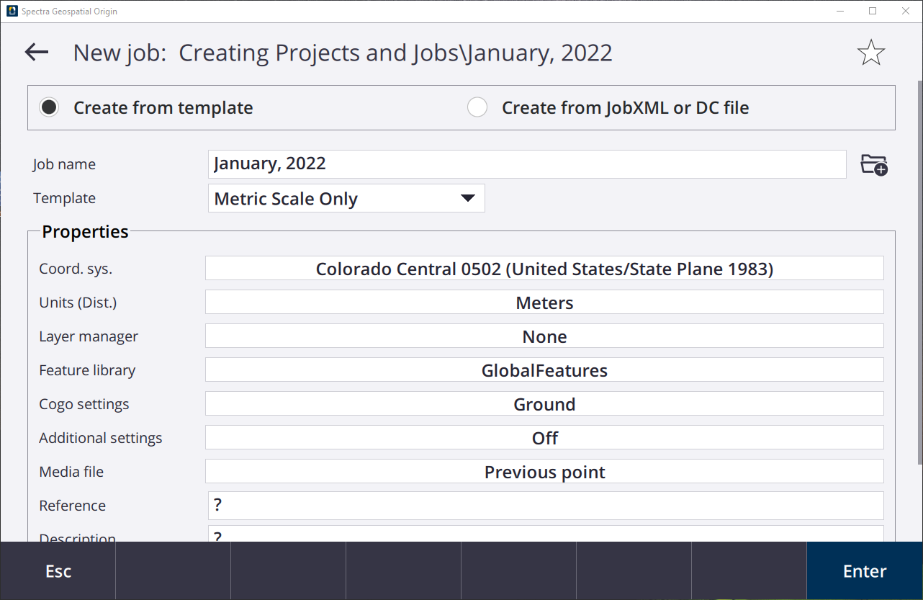
Note: If you have a previous job file that you would like to use as a template, select “Create from JobXML or DCfile” and locate the previous job.
Tip: There are various job templates to choose from: International Feet Scale Only, US Survey Feet Scale Only, Metric Scale Only, Last used job, or you can create a new job based on a previous job’s settings. You can also create a template easily from a calibrated job from Settings / Templates, and then use that template to create new jobs ready with the correct coordinate system parameters. See the Help for more information.
- Now that the job properties are filled in, tap Accept to begin working and you will be brought to the Map screen.

Step 3: Creating a New Job in the Project
- Tap.
In the left panel, you will see the project and job names displayed at the top. Tap the current project to view the project list and navigate the projects, subfolders, and jobs on your controller.
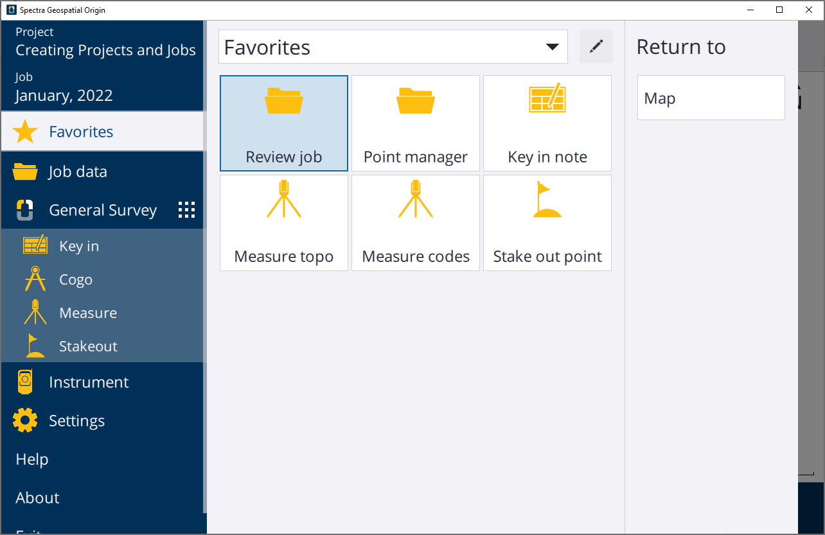
- Tap the job name, which will bring you to the project screen: Creating projects and jobs.
From this screen, you can:
  - Create a New job in this project
  - Create project subfolders - tap 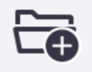
  - Navigate subfolder - tap , or existing folders
  - Change the status of a job to New, In progress, or Field work complete
  - View or change the Properties - tap Properties at the bottom of the screen.
  - Import data - tap Import at the bottom of the screen.
  - Export data - tap Export at the bottom of the screen.
  - Copy job files to different folders including USB drives, copy job files from another existing job, or copy data into another job.
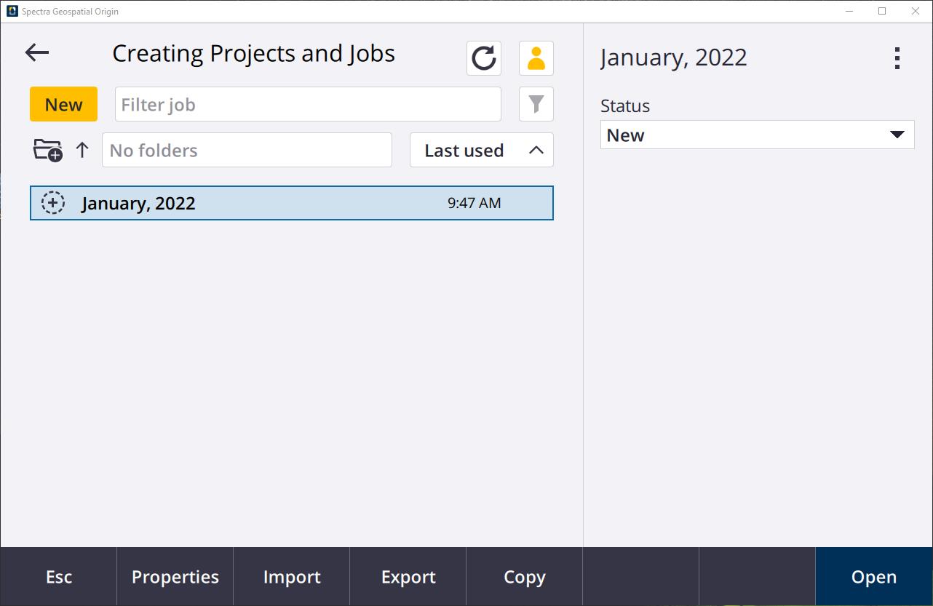
- Tap New to create a new job.
- Give the job the same properties as the first job:
Note: If you would like to import your own data, set your coordinate system up with your projection.
Name: Survey at Trimble Office
Template: Metric Scale Only
Coord. sys. and tap Select from library, which will bring you to the coordinate system database. Input the coordinate system you will be using.
System: United States/State Plane 1983
Zone: Colorado Central 0502
Project Height: 1,641m (meters) - this defines the elevation of your job
Tap Enter and Store.
Units: Meters
Feature Library: GlobalFeatures
Cogo settings: Ground
Tap Accept.
- Tap then the job name and you will see the new job you just created.
You can easily jump to the Project screen, by tapping the Project name, or the Job screen, by tapping the Job name.
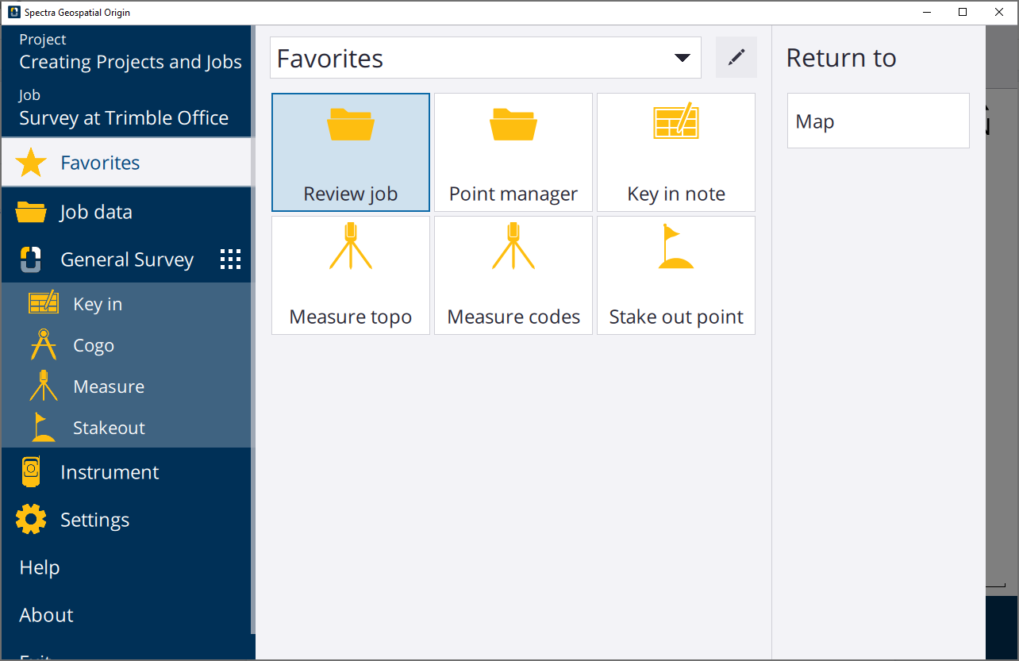
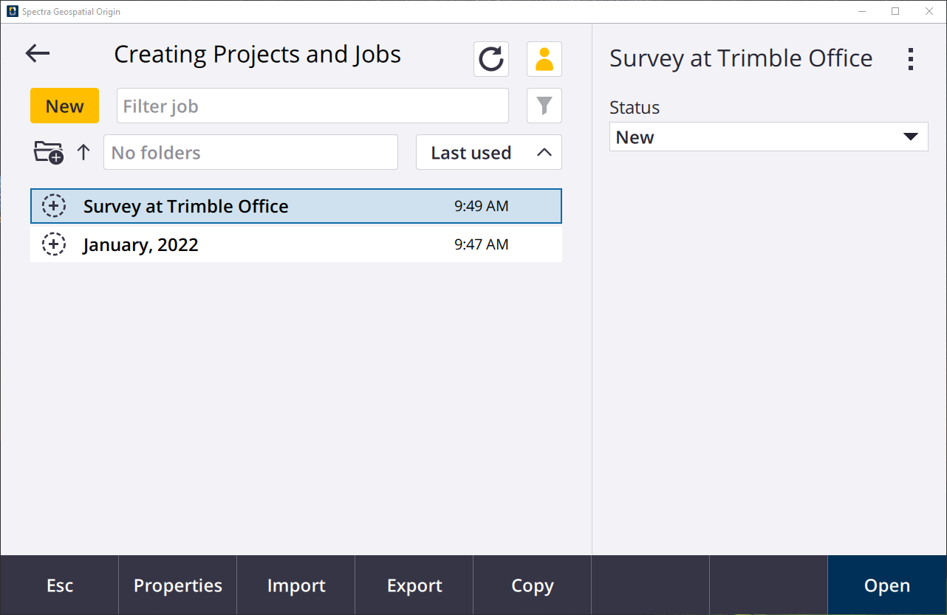

Step 4: Importing Data into a Job
Currently, you have one project with two empty jobs. Now, you will add in field data from a traverse survey. When you import a data file, the points will become a part of the job.
To complete this step, ensure the data is on your device and in a location you can easily navigate to.You can import your own data or use the data provided in the folder downloaded.
- Ensure the data is on your device and in a location you can easily navigate to.You can import your own data or use the data provided in the folder downloaded.
- On the Projects screen, select the Survey at Trimble Office job.
Tap Import.
- In the Import screen:
Change the File Format to CSV Grid Points N-E.
Tap the folder next to File Name and navigate to the project folder on your device.
Select TrimbleControl_M.csv.
Check Import points as control.
- Tap Accept.
A pop-up will appear, notifying that the transfer of data is complete.
- On the Project screen, highlight the Survey in Trimble Office and tap Open.
The Map screen will appear with the points from the imported CSV file. Zoom into the data using the map screen commands.
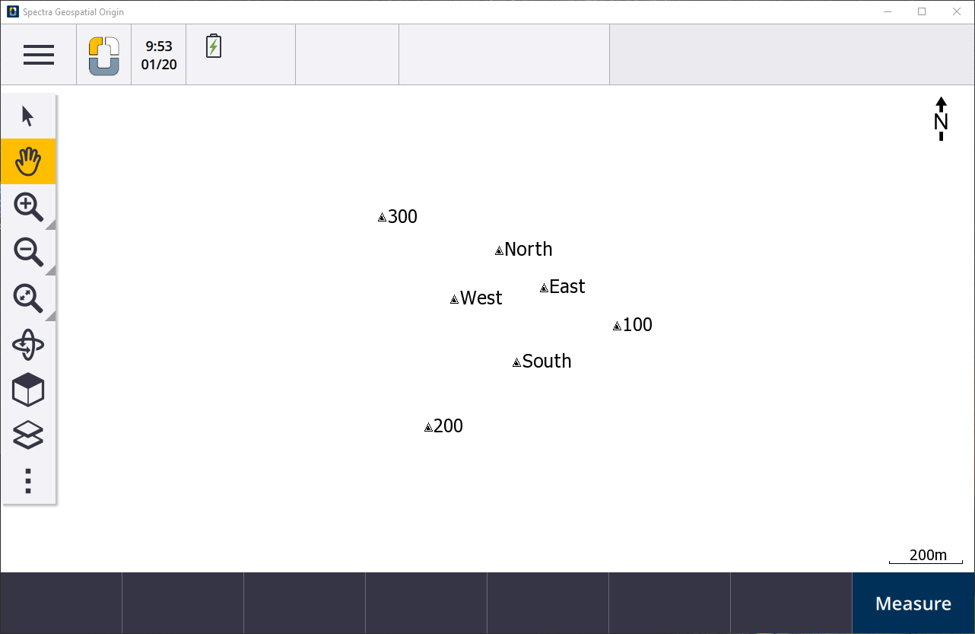

Step 5: Upload Job to Trimble Connect
When signed into Connect, the job can be directly uploaded to the cloud. To learn how to export to your device, skip to Step 4.
- Tap.
- Navigate to the project screen for the Creating Projects and Jobs project.
- On the right, you will see the job status is set to New.
- Change the status of the job to In Progress or Field Work Complete
The job file is now uploaded to the cloud.

Step 6: Export a Job
- Return to the Menu by tapping.
- Navigate to the project screen for the Creating Projects and Jobs project.
- Tap the Survey at Trimble Office job and tap Export.
- In the Export screen:
Change the File Format to JobXML.
For File Name tap the folder icon and save it to the tutorial folder and leave the name the same.
- Tap Accept and a pop-up will appear saying “JobXML Transfer Complete”.
- If you would like to upload the job to Trimble Connect from your device, navigate to the Trimble Connect Sign In page and sign in with your credentials.
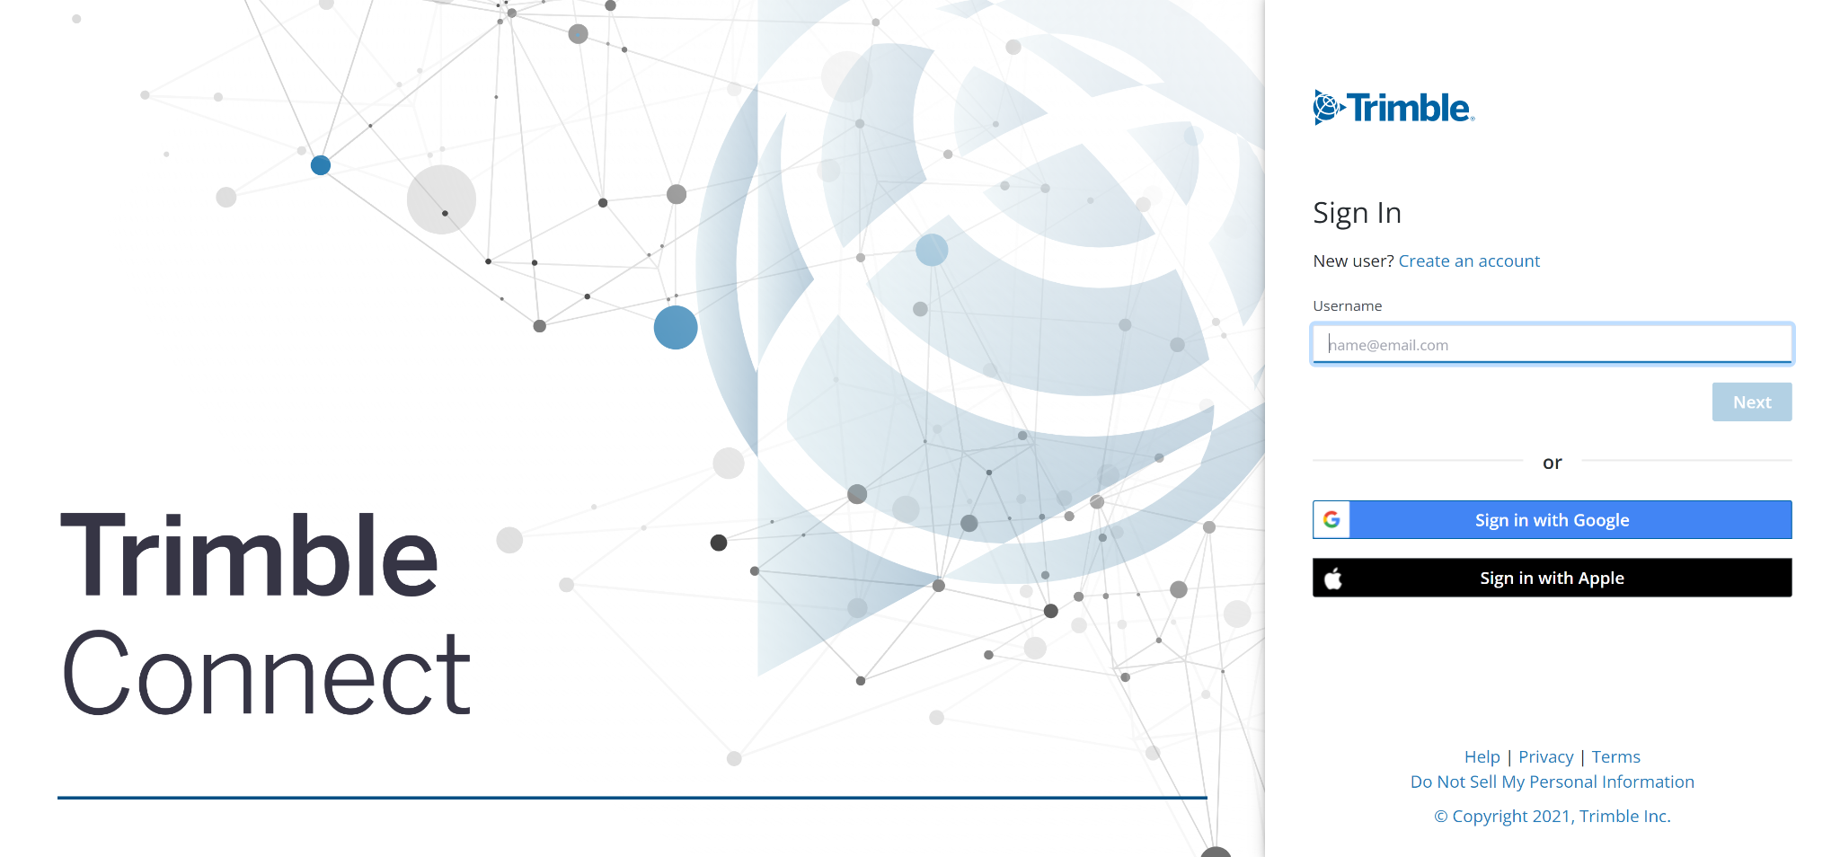
- Open the Origin Tutorials project.
Or create one by pressing New if you did not make one already.
- In the new folder, tap Add and Upload Files.
Drag and drop the new JobXML file.
- The job file is now in your Trimble Connect cloud and you can access it when needed and bring it back into Origin.

You have completed this tutorial.

