*Cover page*

About this Tutorial
In this tutorial, you will learn how to set up shortcuts using Favorites and Function (Fn) tools. Favorites and Functions enable you to create shortcuts to software screens, map controls, or to enable/disable an instrument or receiver function.
This tutorial will take about 10-15 minutes to complete.

What You Will Need
- Origin Field Software: Origin LT, Origin Max, Origin GNSS, or Origin Total Station
- Device: computer or data collector

Step 1: Create a Project and Job
Note: Choose and open any job in Origin, if you do not have a job follow the steps below to create one.
- In the Projects screen, tap New.
- Fill in the project details:
Name the project “Adding Pages to Favorites”
(Optional) Provide a Description “Origin Favorites Screen ”
- Tap Enter and Create
- Name the job Map Screen Commands
You do not need to input any other settings for this tutorial.
- Now that the project is open, you are brought to the Map screen.

Step 2: Add Pages to Favorites List
In this section, you will add and delete tools and pages from your favorites list. The favorites list provides an easy shortcut to pages and tools you frequently use. You can add, delete, and rearrange the list of favorites.
- Tap and select Favorites.
- Tap and you will be brought to the Edit page for your favorites. Origin has default favorites that have already been created.
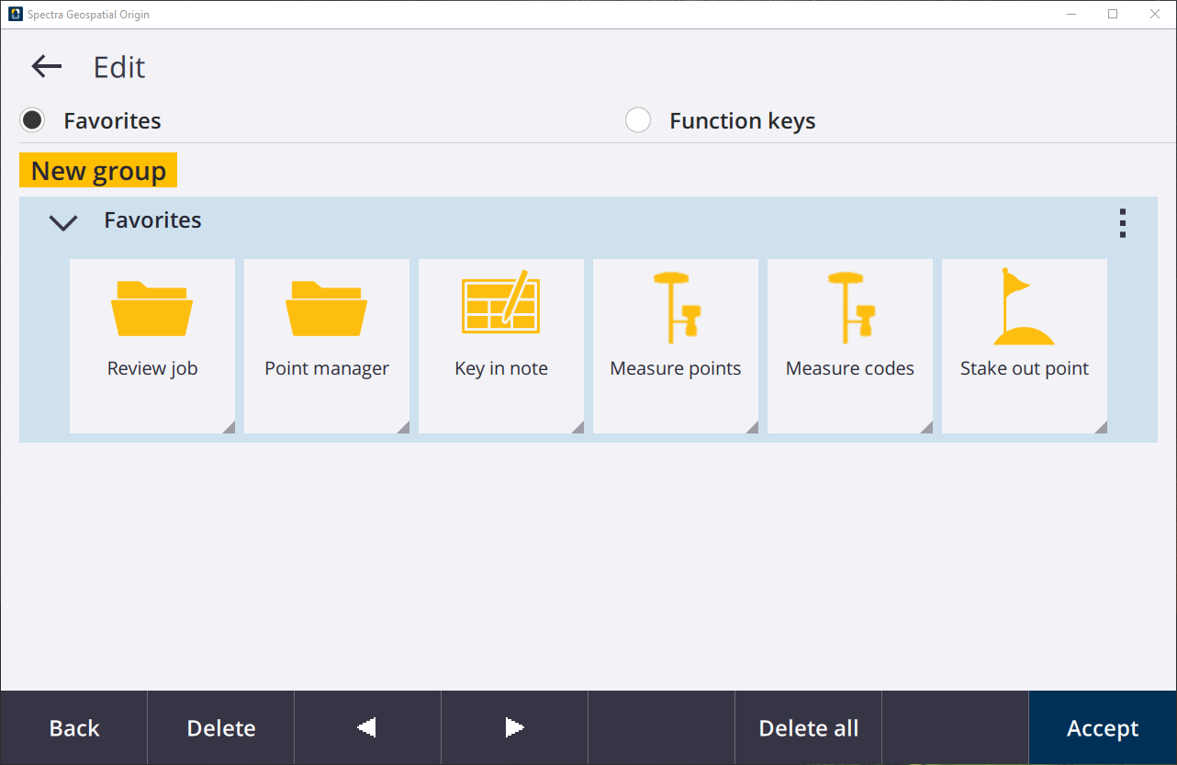
- To rearrange the icons, use the two arrows at the bottom of the screen.
Select Review job and move it to the end of the list.
Tap Accept and go back to the Favorites tab. You will see the new arrangement.
- Tap to go back to the Edit screen.
- Now, you will delete icons from your Favorites list.
Tap the Point manager icon and tap the Delete softkey at the bottom of the screen.
Do the same for Key in note and Review job.
- Tap Accept and go back to the Favorites tab to see the changes
Go back to the Edit screen.
- We will now bring back those favorites that were deleted. In the edit screen, tap .
Select Defaults and a pop-up will appear saying “Do you want to restore the default favorites for Favorites?” tap Yes.
The deleted favorites will re-appear.
- Now you will add the Key in - points and Cogo - Compute points page to your favorites list.
- Tapand select Key in, under General Survey.
In the Key in menu, tap Points
- You will be brought to the Map and the Key in point tab will appear.
Tap the star next to the title.
A drop down menu will appear, select Favorites to add this page to your favorites.
- Tapand select Cogo, under General Survey.
Tap Compute point and tap Bearing and distance
- You will be brought to the Map and the Compute point tab will appear.
Tap the star next to the title.
A drop down menu will appear, select Favorites to add your favorites list.
- Navigate back to the Favorites tab to see the newly added favorites.
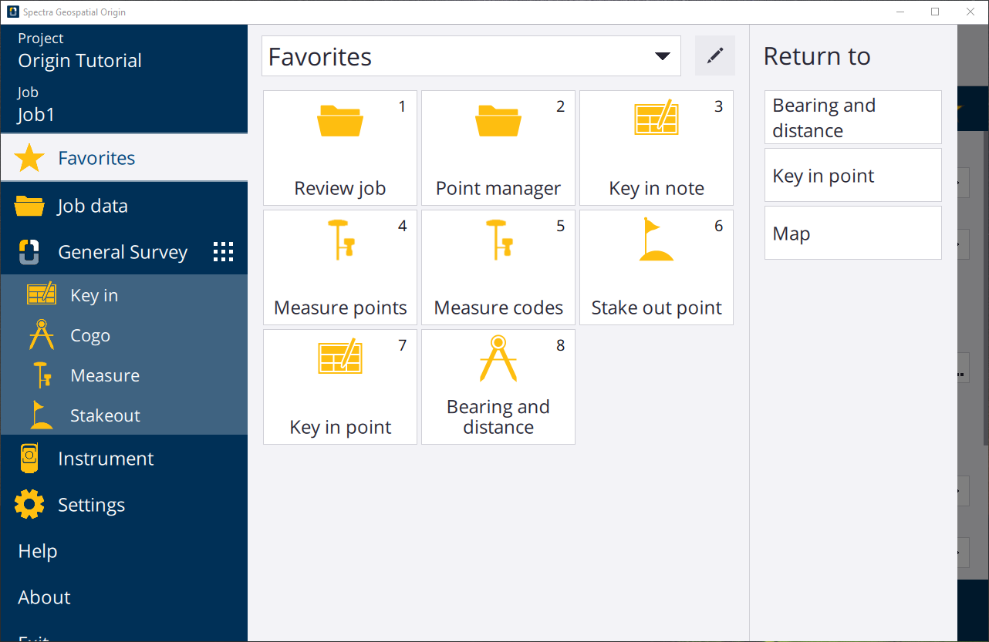

Step 3: Assign Items to Function (Fn) Key
- From the Favorites screen, tap to go to the Edit page.
- Select the Function keys option. Currently, F1 is assigned to Help, which brings you to the Spectra Geospatial Help Portal.
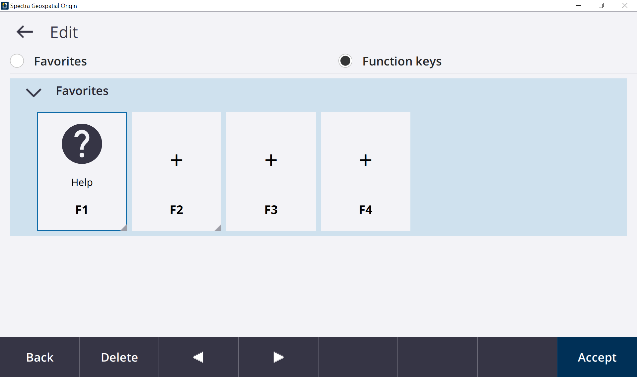
- Tap F2 and you will be brought to the Assign special functions screen.
From here, you can select a command to assign to the function key.
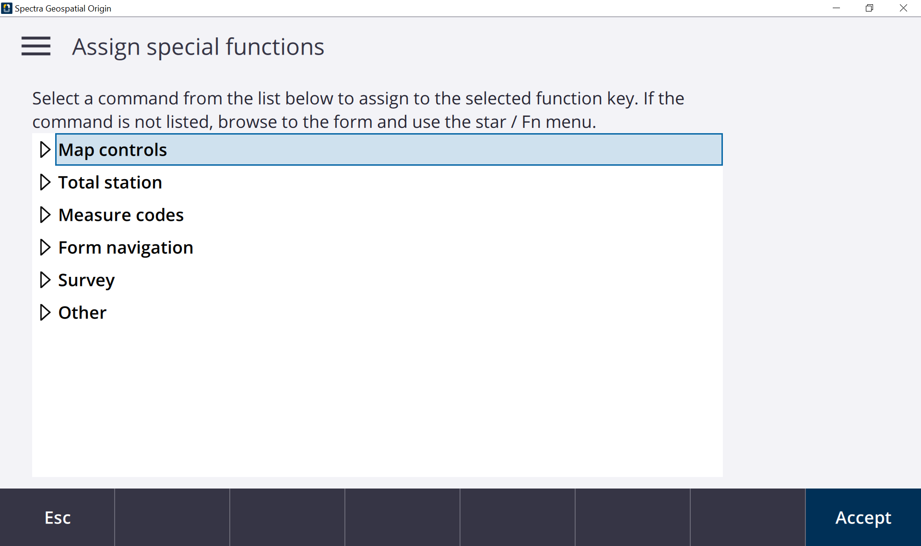
- Select Layers manager under the Map controls.
Tap Accept
- Repeat steps 3 - 4 to assign F3 with the Toggle Measure auto F1/F2 command, under Total station.
- You can also assign the commands to the function keys using the . Navigate to the Point manager screen, tap the star in the top right corner of the screen and a drop down menu will appear.
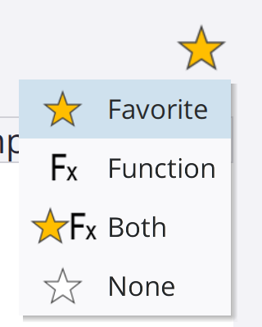
- Select Function and you will be brought to the Select key to assign function to page.
Select F4.
You have assigned all of the function keys to a command.
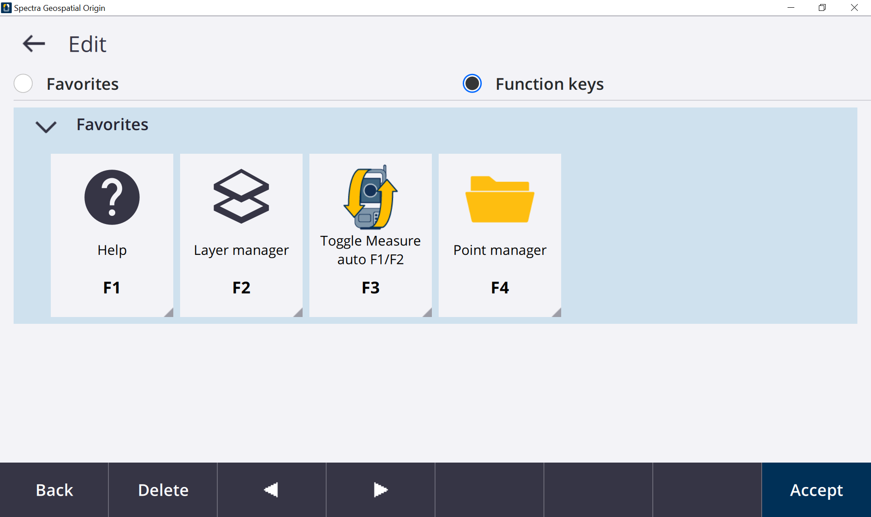

Step 4: Create a New Favorites List
- Go to the Edit screen for your favorites.
- Tap New group and in the new section, change the name to “Tutorials”
- Tap the three dots and select Defaults and Yes to the pop-up message.
- You are also given the option to “Auto-switch when using GNSS” or “Auto-switch when using conventional”. By setting this up, you can have your custom favorites tab needed for each type of surveying.
For the Tutorials favorites, select Auto-switch when using GNSS.
- For this tutorial, you will just have the default favorites.
In the drop down menu, select Defaults and Yes to the pop-up.
- Go back to the Favorites page.
- Using the dropdown menu, you can switch between the Favorites and Tutorial.
- Depending on the type of survey you are doing, create your own favorites menu. This can help save time out in the field by having easy access to your frequently used pages and tools.
You have completed this tutorial.

