*Cover page*

About this Tutorial
In this tutorial, you will learn how to set up a Radio RTK Survey, connect to a rover, and connect to a base station.
This tutorial will take about 10-20 minutes to complete.

Radio RTK Survey Style
In Origin, to connect to a GNSS receiver, you need to define a survey style. A survey style defines the model of GNSS receiver you are going to use and the way you are going to use it.

What You Will Need
- Origin Field Software: Origin Max or Origin GNSS
- Device:
  - Computer or data collector
  - GNSS Receiver - this tutorial uses Spectra’s SP60 GNSS Receiver
  - Base Station
  - Radio
- Geoid: You will need to have a geoid for this tutorial. This tutorial was made using the GEOID18 (Conus) (g18us.ggf) geoid file. Please use the geoid that matches your area. Here is a link to various geoid files. Once you have the geoid file downloaded, the file needs to be moved into the system files folder in the Origin application. Please use the following steps:
- Download and copy Geoid file to data collector
- Open the Spectra Geospatial Origin folder (or Spectra Geospatial Emulator for a desktop)
- Open Spectra Geospatial Data folder
- Open System Files folder and paste geoid file

Step 1: Create a Project and Job
Note: If you have a project folder in Trimble Connect, open the project and create a new job.
- In Origin, you will be brought to the Projects page. Tap New in the top left hand corner of the screen.
The New project screen will display.
- In the New [project screen, fill in the project details (not all of the details are required).
Name the project “RTK Radio Survey ”
(Optional) Provide a Description “starting a RTK Radio Survey”
(Optional) Provide a Reference
(Optional) Include a Location “Westminster, CO”
(Optional) Include an Image
- Tap Enter and Create
- In the New job: RTK VRS Network Survey/ screen, use Create from template and set up the job with these details:
Job name - “Starting a RTK Radio Survey”
Template - Metric Scale Only
Tap Coord. Sys.
Tap Select from library
System - United States/State Plane 1983
Zone - Colorado North 0501
Geoid - Yes
Geoid model - GEOID18 (Conus) (g18us.ggf) - refer to steps for implementing the geoid file into the Origin System Files on your device.
Project height - 1524m; Tip: If you know the project height in US Feet, type height XX sft, and it will automatically adjust to meters.
Units (Dist.) - Meters
Feature library - GlobalFeatures
Leave all of the other properties to the default (or empty) value.
- Tap Accept.
- Once you have opened the project, you are brought to the Map screen.

Step 2: Create a Survey Style
This tutorial uses an SP60, fill in the information with the instrument you are specifically using.
- Tap .
- Scroll down to Settings and tap Survey styles.

In the Survey styles screen, you will see a list of previously used survey styles and the date it was last modified.
- At the bottom of the screen, tap New to create a new survey style.
The Style details screen will appear and there is a location to provide a Style name and Style type.
- Change the Style name to RTK Base and the Style type to GNSS
Tap Enter and Accept
- The RTK Base page will appear, where you can configure settings for the survey style.
- Tap Rover options and change the following settings (change to fit your device):
Survey type to RTK
Broadcast format to CMRx or the broadcast format for your radio .
Under Antenna settings,
Change the antenna Type to your rover
Choose your preferred Measured to preference
Input Antenna height
Note: Only enter an antenna height if you want to set a default when starting a survey.
Under GNSS Signal Tracking, check the satellites available for your area. This tutorial uses: GPS, GPS L2C, GLONASS and Galileo.
- Tap Accept and you will be brought back to the RTK Base screen.
- Tap Rover data link. This will define the way corrections to the rover are received.
Change Type to Radio and change Radio to Receiver internal.
- Tap Connect to connect to your rover and change the radio frequency.
A pop-up will appear saying Connecting to GNSS rover via cable - Bluetooth: None.
Tap Settings in the pop-up window and you will be brought to the Connections tab.
- On the Connections page, ensure you are under the Bluetooth tab to connect to your rover and base station.
- To connect to a new rover, tap Search at the bottom of the screen
Note: if you have already connected to this rover before, just select your rover from the drop down menu under Connect to GNSS Rover.
- On the Bluetooth Search screen, there are two columns showing a list of Discovered Devices and Paired devices.
Under Discoverable devices, tap the rover you would like to connect to.
Tap Pair.
- A pop-up will appear saying A new device has been paired. Ensure the Device name is correct and Device type is Connect to GNSS rover.
Tap Accept.
- You will be brought back to the Rover data link screen.
Tap Connect and the Connecting to radio …. pop-up will appear and load to 100%.
- Origin will prompt you to the Radio configuration screen where you can check and change the radio frequency.
The settings for this page will depend on the radio that you will be using. This survey uses TRIMTALK v1 at 9600 bps at a frequency of 469.55 MHz.
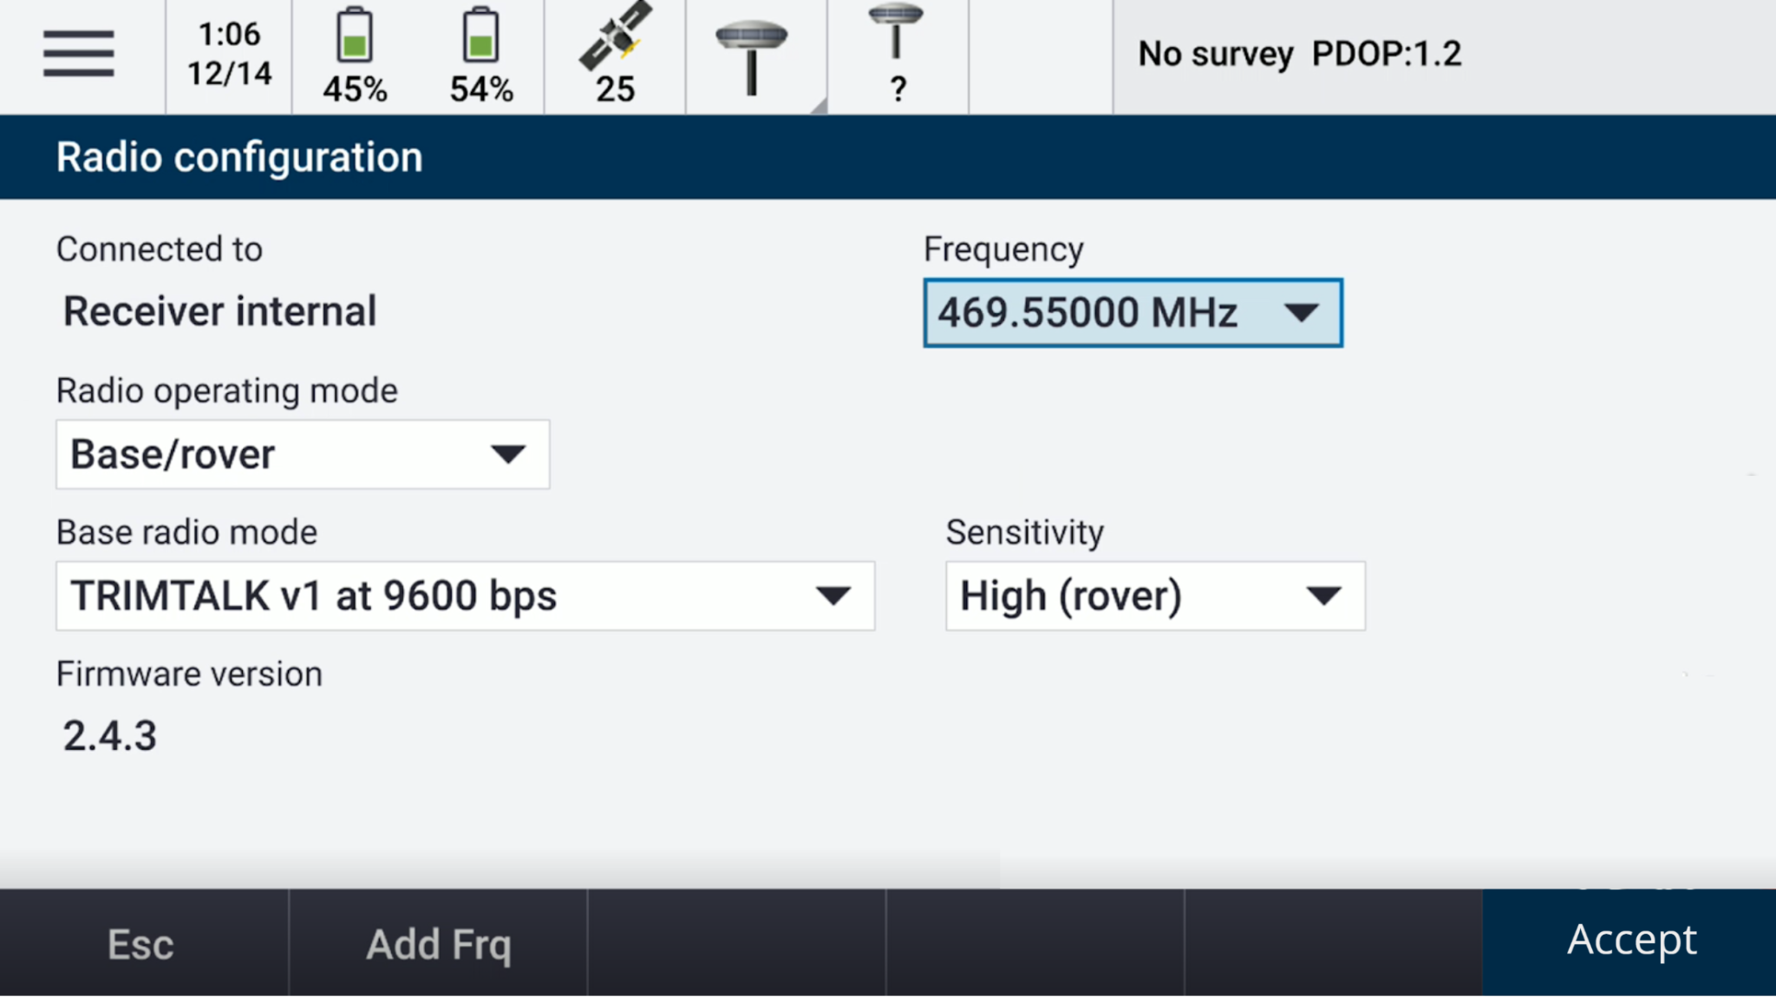
- Once the settings are set up for your radio, tap Accept and a Setting radio… pop-up will appear and load to 100%.
- You will be brought back to the Rover data link page and tap Accept.
- Back on the RTK Base survey style screen, tap Base options.
- Change the Survey type to RTK and Broadcast format to CMRx.
Under Antenna, change the settings to git your antenna:
Type: SP60
Measured to: Bottom of antenna height
Antenna height: 2.0m
Tap Accept.
- Tap Base data link on the RTK Base survey page.
Type to Radio
Under Radio, select the radio you will be using and fill in the settings for your radio.
Tap Accept
- Now that the rover and base station is defined, tap Store.

Step 3: Start the Survey
- Tap .
- Tap Measure, then Radio RTK, then Measure points
- Two pop-ups will appear: Connection to GNSS rover via bluetooth - Bluetooth: SP60_XXXXXX (your device) and Starting survey … that will load to 100%.
- The map screen will appear again with the Measure points tab open on the left.
- One you have an RTK Fixed solution, an Initialization Change pop-up will appear saying Initialization has been gained.
Tap OK.
- You are now ready to begin your survey.

You have completed this tutorial.

