*Cover page*

About this Tutorial
In this tutorial, you will learn how to create a conventional survey and connect to a Focus 30/35 total station.
This tutorial will take about 10-20 minutes to complete.

Using a Total Station with Origin Software
To Connect to a total station with Origin, you will need to start a conventional survey, with a survey style set up for the model on instrument. The survey style defines the total station and how you are going to use it. The functionality available in Origin depends on the model and firmware version of the connected instrument.

What You Will Need
- Origin Field Software: Origin Max or Origin Total Station
- Device:
  - Computer or data collector
  - Focus 30 or 35 Total Station

Step 1: Create a Project and Job
Note: If you have a project folder in Trimble Connect, open the project and create a new job.
- In the Projects screen, tap New.
- Fill in the project details:
Name the project “Connecting to a Total Station ”
(Optional) Provide a Description “start a conventional survey with a total station”
- Tap Enter and Create
- In the New job: Connecting to a Total Station screen, use Create from template:
Job name - “Focus 35”
Template - Metric Scale Only
Tap Coord. Sys.
Tap Select from Library
System - United States/State Plane 1983
Zone - Colorado North 0501
Project height - 1524m; Tip: If you know the project height in US Feet, type height XX sft, and it will automatically adjust to meters.
Units (Dist.) - Meters
Feature Library - GlobalFeatures
Leave all of the other properties to the default (or empty) value.
- Tap Accept.
The properties for that job will be carried over.
- Once you have opened the project, you are brought to the Map screen and you can see the data in the map view.

Step 2: Select and Create a Survey Style
- Tap
- Scroll down to Settings and tap Survey styles.

In the Survey styles screen, you will see a list of previously used survey styles and the date it was last modified.
- At the bottom of the screen, tap New to create a new survey style.
The Style details screen will appear and there is a location to provide a Style name and Style type.
- Change the Style name to Focus35 (name this style name based on your type of total station) and the Style type to Conventional
Tap Enter and Accept
- The Focus35 page will appear, where you can configure settings for the survey style.
- Tap Instrument. This is where you will define the instrument and change the instrument settings.
- Change the following settings to fit your total station. This tutorial uses the Focus35:
Manufacturer to Spectra Geospatial
Model to FOCUS 30/35.
We will accept the other default settings.
Tap Accept.
- You will be brought back to the Focus35 screen.
Tap Store and Esc.
- Tap and then Settings.
- Tap Connections where you will set up the connection between your controller radio settings to connect to the conventional instrument.
- Navigate to the Radio settings tab and change the following settings to fit your settings:
Radio channel to 10 (or whichever radio channel you need to use).
Network ID to 100 (or whichever network ID you need to use).
- Tap Options and you will be brought to the Radio settings page.
Change the Controller port to Internal radio
Tap Accept
- Navigate to the Auto-connect tab and Check GNSS Receiver and Focus 30/35.
- Tap Accept and Esc to return to the Map screen.
- From Map screen, tap Measure
Tap Focus35 survey style
Tip: If there is only one survey style it is automatically selected for you.
Tap Station setup
- Fill in the information to complete a Station setup
Note: Origin will automatically start looking and connect to the Focus 35 total station.

Step 3: Level the Total Station
- Tap the instrument icon of the Total station at the top of the screen and the Instrument functions screen will appear.
Note: This may automatically appear, if not then use the total station icon.
- Tap Level and the Electronic level screen will appear.
- Level the total station to an acceptable level.
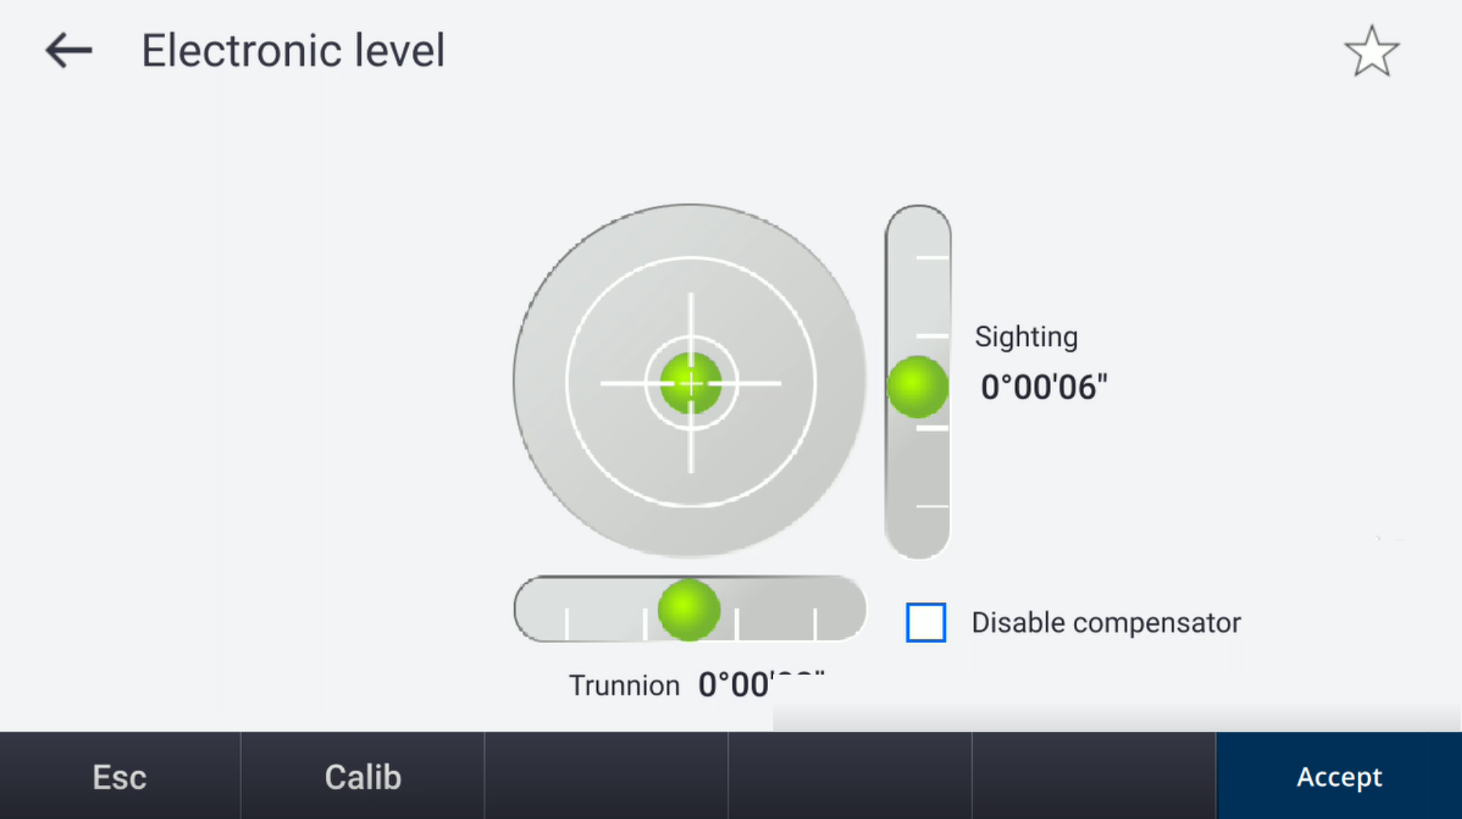

Step 4: Start the Survey
- Tap and tap Measure.
Tap Measure topo and Origin will automatically connect to the Focus 35, if it is not already connected.
- From the map screen, tap the instrument icon of the Total Station at the top of the screen to view the various Instrument functions.
Refer to the Origin User Guide to learn more about the different instrument functions.
- Tap the target icon in the top of the screen, where you can access the target form and define target details.
- If you have not already set this target up before, tap an empty target square with a + in the middle to add a new one.
- A new Target screen will appear. Change the following settings to fit your prism:
Target height - 1.2m
Prism type - Spectra Geospatial 360 (change to your prism).
Display name - 360 prism
Tap Enter and Accept
- Back on the Targets page, select the prism you just created.
- From the map, tap Store to store the TRK measurement.
- Continue taking measurements for your survey by changing the code and tapping Store.

You have completed this tutorial.

