*Cover page*

About this Tutorial
In this tutorial, you will learn how to perform a GNSS Site Calibration. We will be using control points, located in Westminster, Colorado (U.S.). You can use this tutorial to follow along with steps; however you will need to use your own local control points to accurately perform these steps.
This tutorial will take about 15-30 minutes to complete.

GNSS Site Calibration
Calibration is the process of adjusting projected (grid) coordinates to fit the local control. A calibration calculates parameters for transforming Global coordinates into local grid coordinates.
Spectra Geospatial recommends using a minimum of four local control points for the calibration calculation; however, you can use a maximum of 200. For best results, local control points should be evenly distributed over the job area as well as extending beyond the perimeter of the site.

What You Will Need
- Origin Field Software: Origin Max or Origin GNSS
- Device:
  - Computer or data collector
  - GNSS Receiver - this tutorial uses Spectra’s SP60 GNSS Receiver
- Survey: You will need to start a GNSS survey to perform a site calibration. Please refer to the tutorials for setting up a new survey, if needed.
- Data: Ensure the data used in this tutorial is located on your device. You should use your own control point data for this tutorial; however, we have provided the control points used in the GNSSSiteCalibration folder you downloaded. You will link the control points to your job.

Step 1: Create a Project and Job
- When you start Origin, you need to select or create a new Project. Tap New in the top left hand corner of the screen.
- In the New project screen, fill in the project details (not all of the details are required).
Name the project “GNSS Site Calibration”
(Optional) Provide a Description “perform GNSS site calibration”
(Optional) Include a Location “Westminster, CO”
- Tap Enter and Create
- In the New Job: GNSS Survey screen, tap Create from template and set up the job with the properties of your site:
Name: GNSS Site Calibration
Template: Metric Scale Only
Coord. Sys. and tap Select from library. Input the coordinate system you will be using.
System: United States/State Plane 1983
Zone: Colorado Central 0502
Project height: 1,641m (meters)
Tap Enter and Store.
Units: Meters
Feature library: GlobalFeatures
Cogo settings: Ground
- Tap Accept.
- Once you have opened the project, you are brought to the Map screen.
- To link the data, tap the Layer manager icon.
- Under the Point files tab, select Browse.
Navigate to the control point file SiteCalibration_Controls.job (or your own control point file)
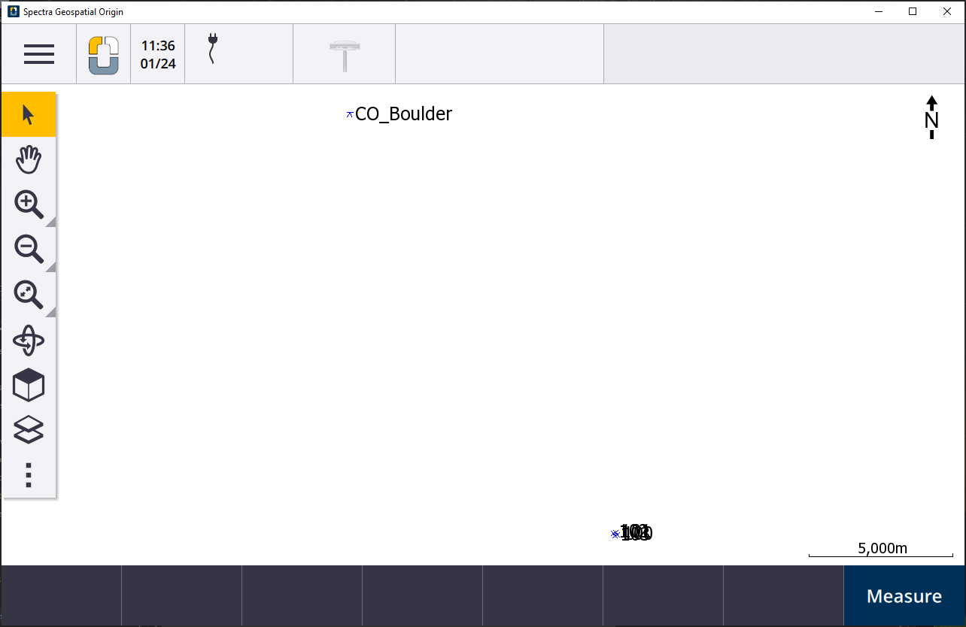
- Center the control points to your screen. You will see four control points in the map: 100, 101, 102, 103. These will be the points calibrated in this tutorial.
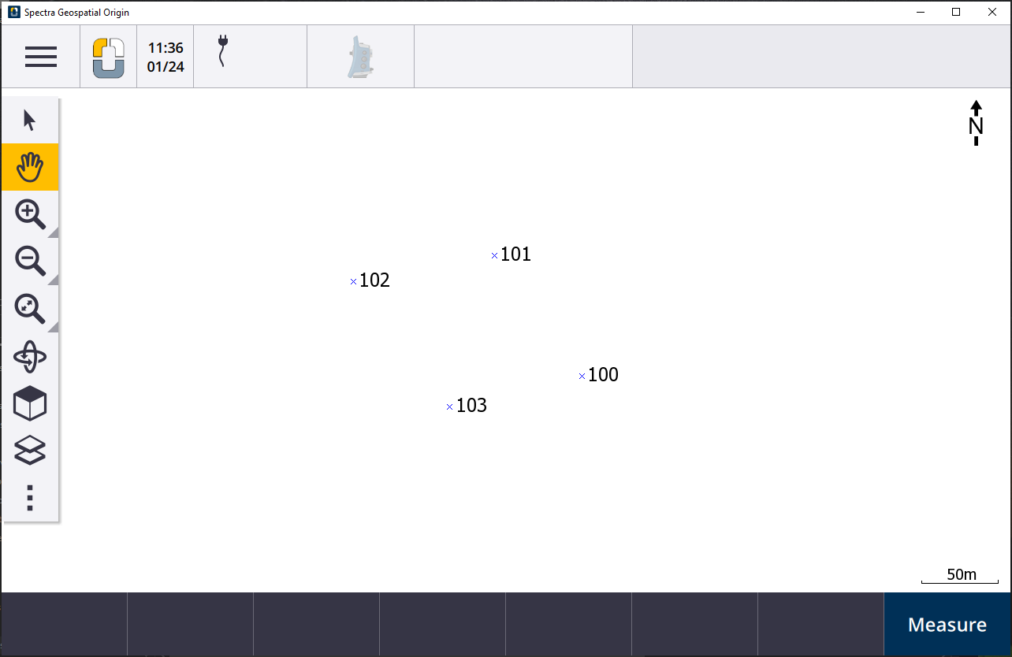

Step 2: Start a GNSS Survey
- Set up the survey style you would like to use.
- If you need assistance, navigate to the Origin Tutorial Page to see:
- Setting up a Radio RTK Survey
- Setting up a VRS Now RTK Survey
- This survey will be using a Network RTK survey style.

Step 3: Measure Site Calibration Points
- Tap .
Tap Measure and Measure points.
- Change the Method to Calibration point and we will first calibrate point 100.
- Tap Options and scroll to Calibration point name
Ensure Method is set to add suffix and Add is set to _GNSS.
Tap Accept.
- In the Grid point name box, type 100. The boxes should auto-fill; however, check to ensure the information is correct:
GNSS point name - 100_GNSS
Code - NAIL
Antenna height - 2.0m (adjust to your antenna height).
Measured to - Bottom of antenna mount (fix to your method)
- Position your GNSS receiver on the marked control point.
Tap Measure and Store once the measurement is taken.
Note: For site calibration, Origin defaults to a 3 minute measurement shot to help with accuracy. You can edit this length to longer or shorter, if needed.
- Once the measurement has been taken, tap Store.
You can take a photo of your calibration point, if desired.
- Walk to the next control point and repeat Steps 1 - 5 to calibrate each control point on your site.

Step 4: Apply Site Calibration and View Results
- Tap .
Tap Measure and Site calibration.
- Tap Add and you are brought to the Calibration point screen.
For GNSS point name, enter 100_GNSS (or tap the arrow to the side of the bar, select List and you will see a list of points)
The Grid point name and Use will auto-fill.
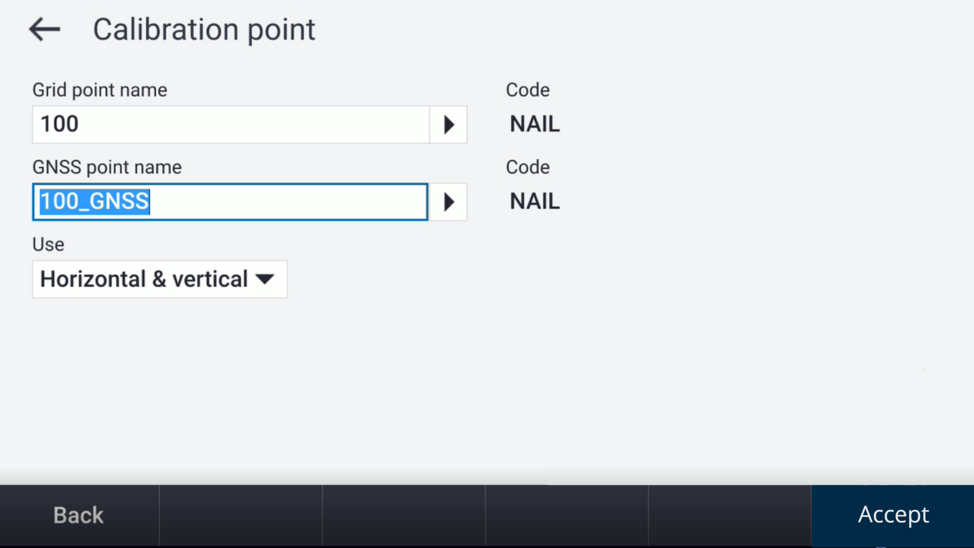
- Tap Accept and repeat Steps 1 - 2 to add all four points to your Site Calibration.
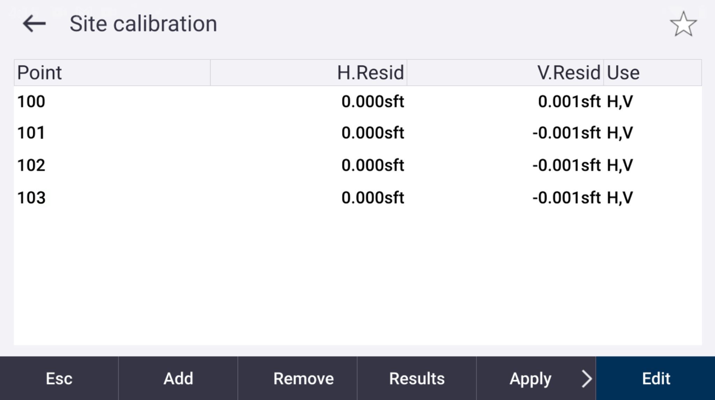
- Once all of your points have been added to your site calibration. Tap Results where you will see the level of accuracy for your calibration.
- Tap Apply to save your site calibration.

You have completed this tutorial.

